Binary Representation Of Negative Numbers.
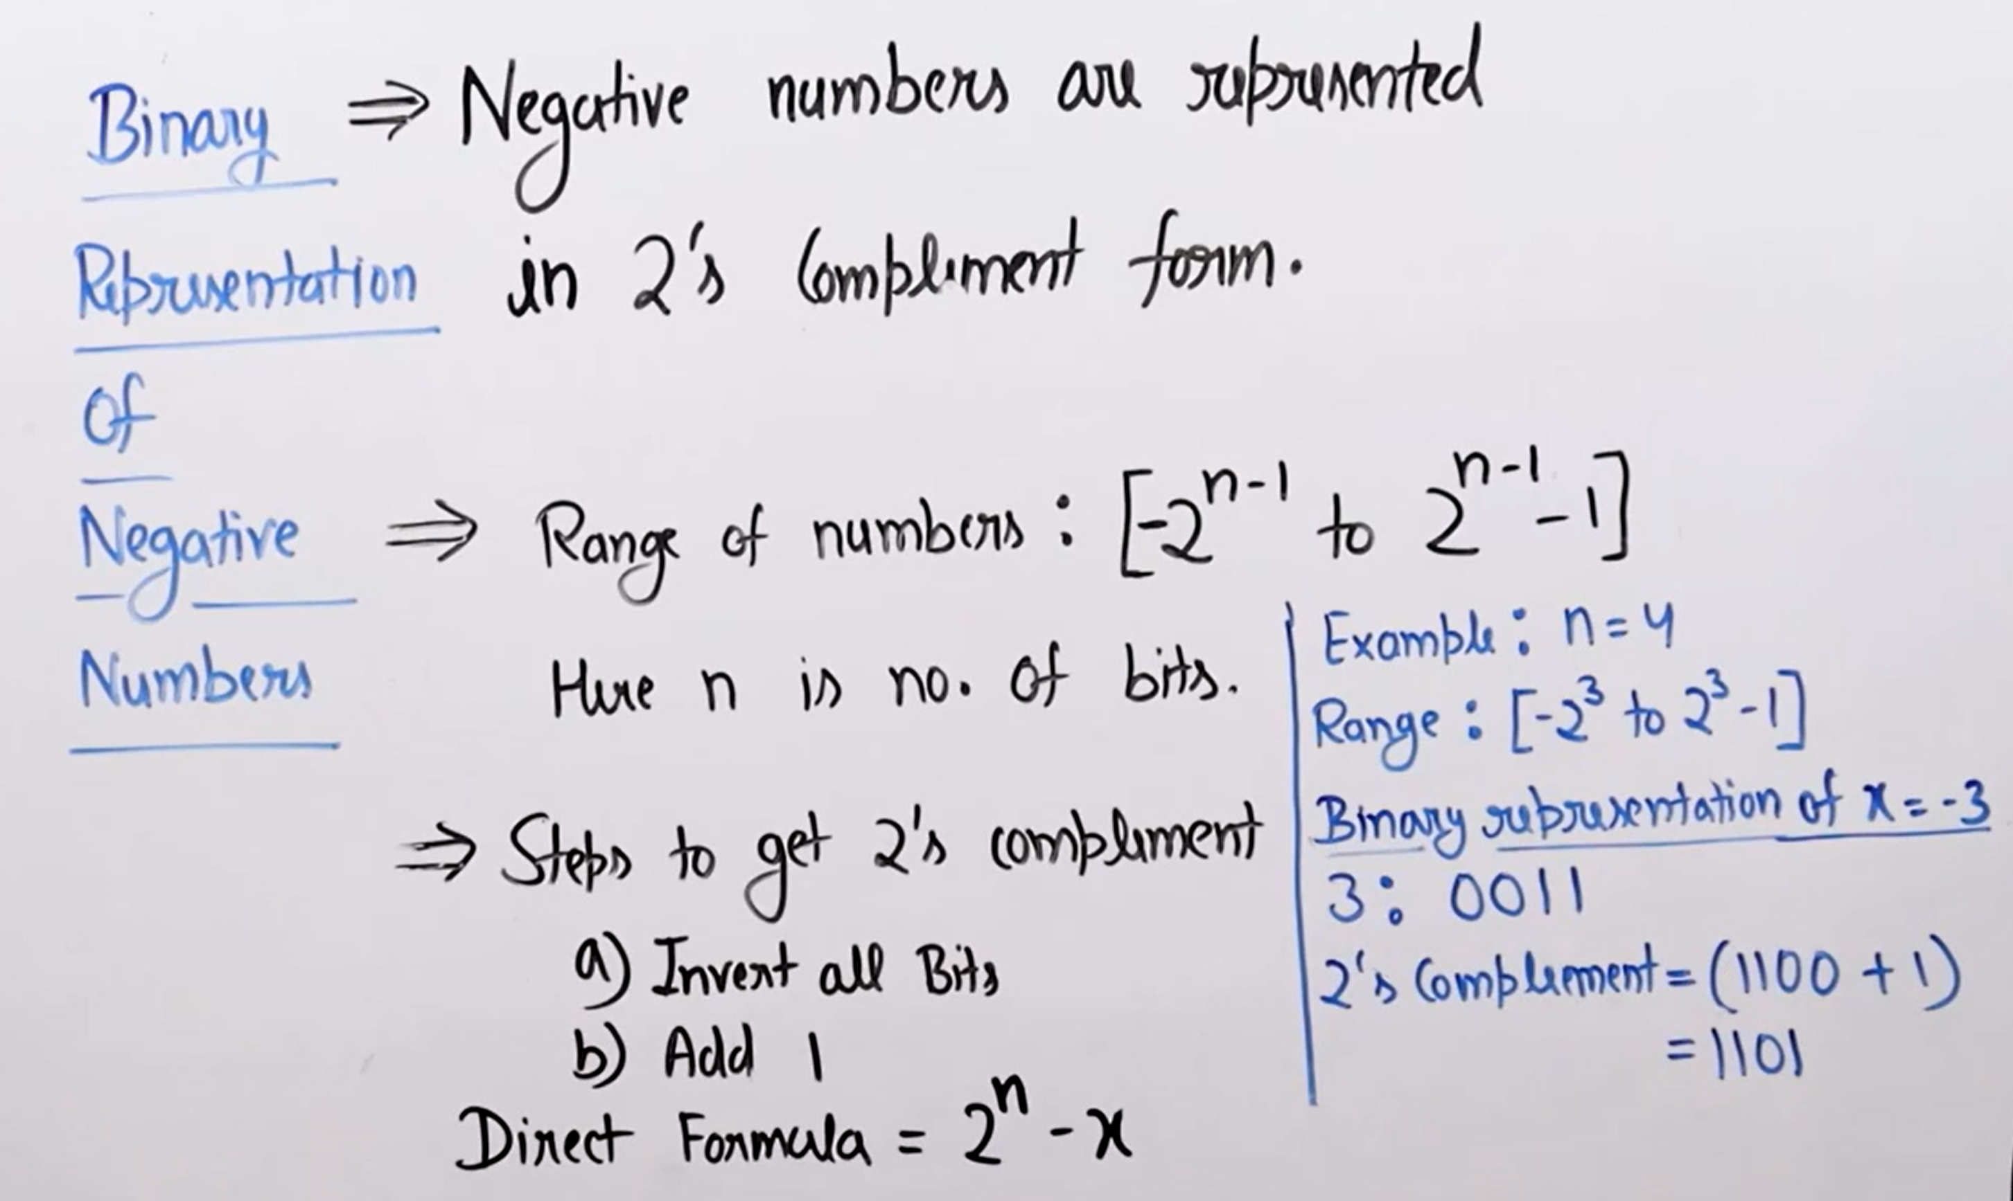
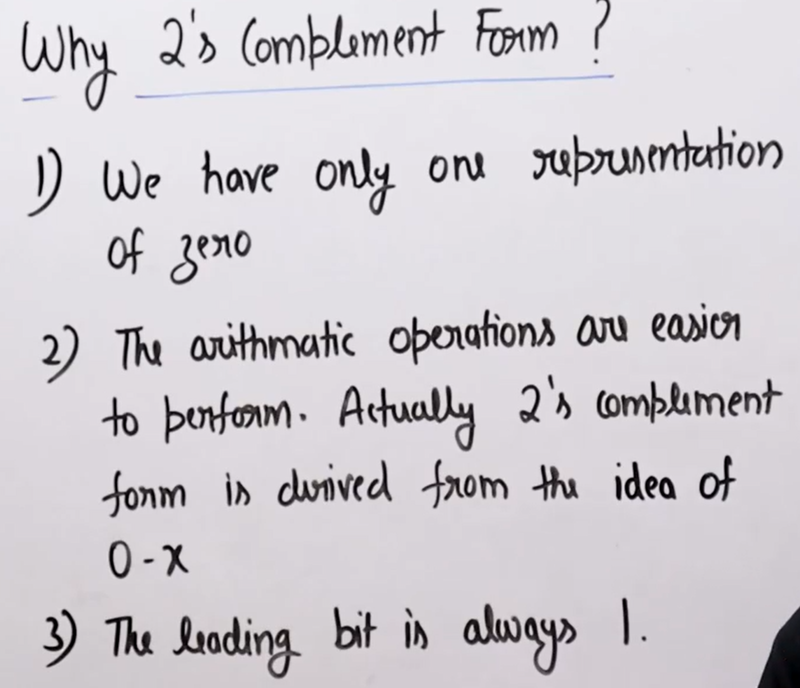
We have the sign bit but for the sign it we represent the positive zero and the negative zero so for that we didn’t use the sign bit.
1’s Complement:

